Automation of Weekly report FOR LINUX & AIX

The scripts in this folder are placed in the location "/usr/local/custom/bin/weekly_report" of centralized server:shepictemsa205 which in turn calls the scripts located at /cfg2html/wreport_LINUX & /cfg2html/wreport_AIX in server shepictscsa205

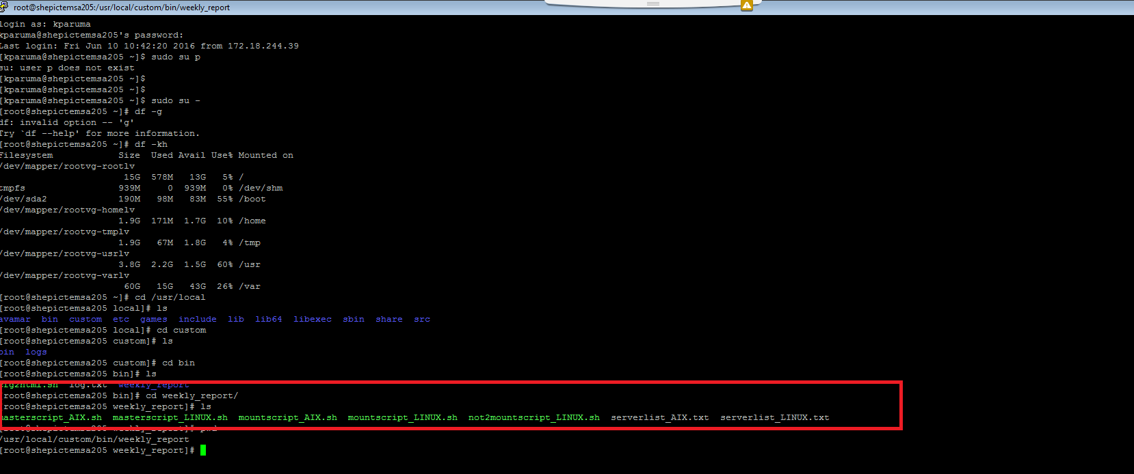

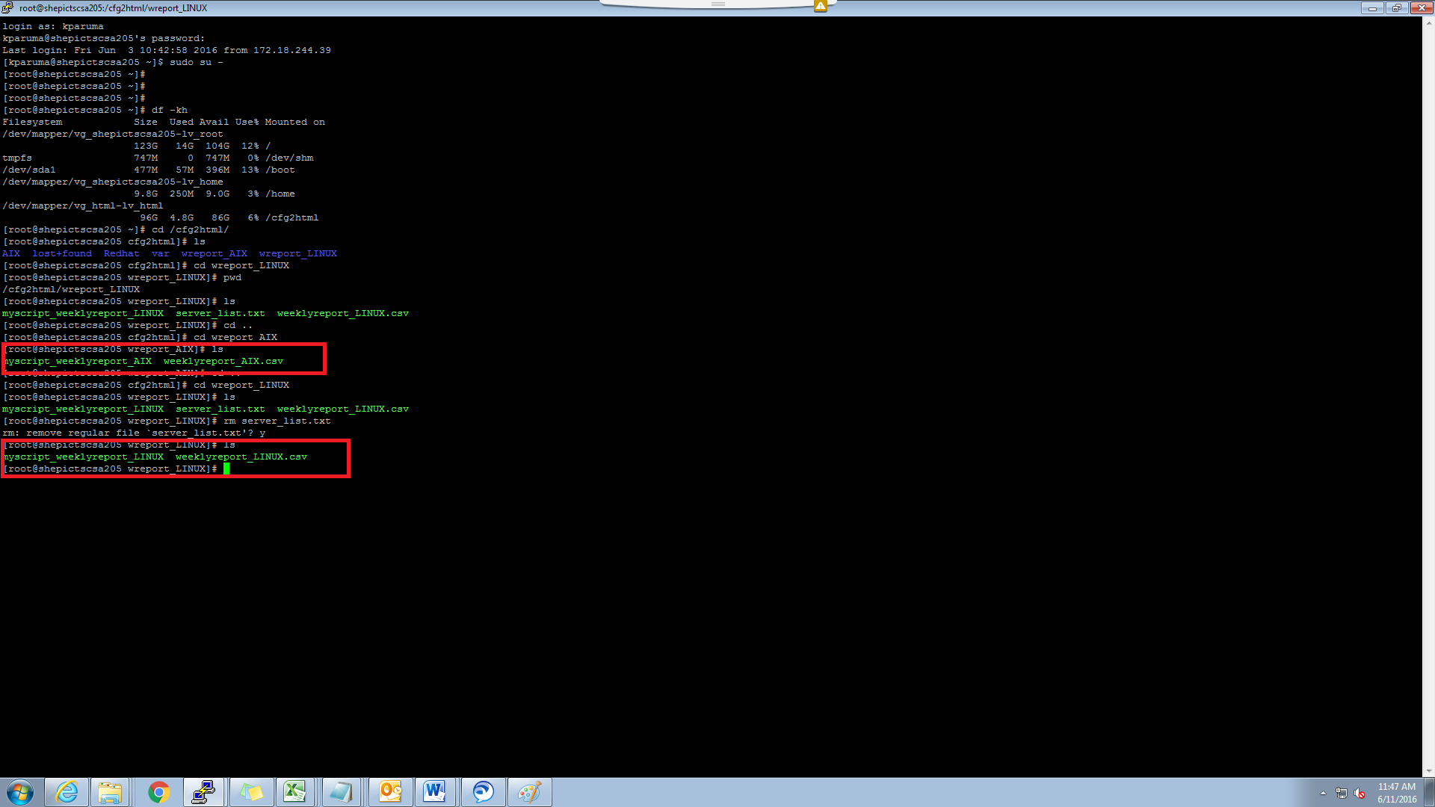

Sample output produced:

